**Day 1 Lab (JS)**

**JavaScript Assignment – Lecture 1**

**Part 1: Variables and Scope**

1. Explain how var works in JavaScript. What is variable hoisting? Give a code example.

- var keyword is used to declare global or function scope variable. the default value is `undefined` if not specified

- hoisting is when the JS interpreter appears to move declarations to the top of the scope (that's why we're able to reference a variable before declaring it)



2. What is the scope of a variable declared with var inside a function? Function scope What about inside a block (e.g., an if statement)? Global scope

- variable declared with var have only one of 2 scopes.

1. function scope (inside a function).

2. any other scope is global scope (if statement, {}, loop, …etc)

3. List all JavaScript primitive types in ES5. Give an example of each.

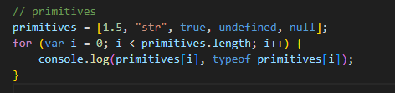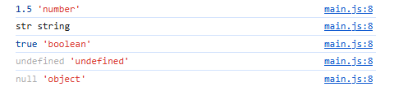

4. What is the difference between a primitive type and an object type? Give an example where this difference is important.

- primitive data types represent single immutable variable that have NO methods of properties. While objects encapsulate both data (attributes) and behavior (methods)

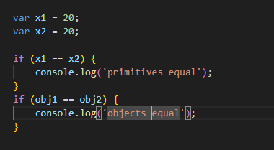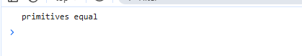

5. Create a number, string, and boolean using both literal and constructor syntax. Show the difference in their types using typeof.

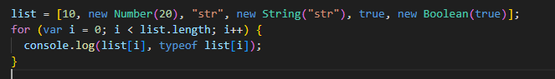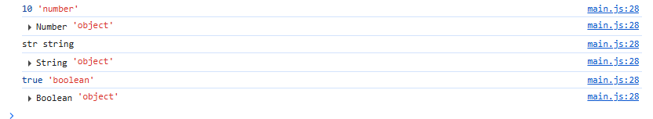

6. Why is it generally recommended to use literals instead of constructors for primitive types?

- for simplicity, clarity, and readability

7. Given the following code, what will be the output? Explain why.

var x = 123.4567;

console.log(x.toFixed(2));

console.log(x.toPrecision(4));

- output:

- 123.45 🡪 round to 2 digits

- 123.4 🡪 get the first 4 digits

8. What is NaN? How can you check if a value is NaN? Give an example.

- NaN is a value that represents a value that the result should be number, but it’s not.

- check using Number.isNaN()

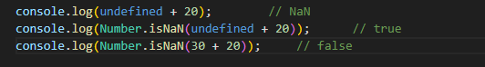

9. What is the difference between parseInt, parseFloat, and Number? Give an example for each.

- parseInt(): parses an integer from a string (get the numerical part)

- parseFloat(): parses a float from a string (get the numerical part)

- all parse methods reads a string from left to right (after removing spaces after and before the value if exist)

- Number(): convert value to a number if possible

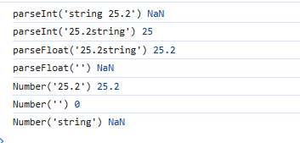

10. What is the difference between implicit and explicit type casting? Give an example of each.

- explicit type casting happens based on a user statement (on purpose). While implicit casting is done by the interpreter

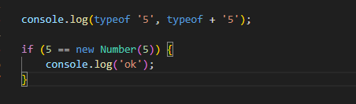

11. What will be the result and type of the following expressions? Explain your answer.

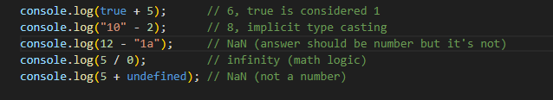

12. What will be logged to the console in the following code? Explain each step.

var a = "15.5";

var b = +a;

console.log(b, typeof b);

* Output 🡪 15.5 number

- (+a) is an explicit type casting to number

13. What will be the output of:

var result = 20 > true < 5 == 1;

console.log(result);

- output 🡪 true

- explanation:

- 20 > 5 🡪 true

- true (1) < 5 🡪 true

- true == 1 🡪 true

14. Write a function that takes a string and returns true if it can be converted to a valid number, and false otherwise.

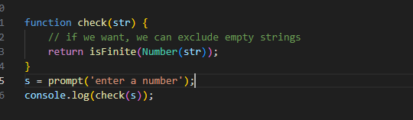

15. Write a program that prints all numbers from 1 to 20 using a while loop.

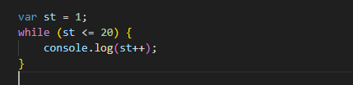

16. Write a program that asks the user to enter numbers until they enter 0, using a do...while loop. After the loop ends, print the sum of all entered numbers (excluding 0).

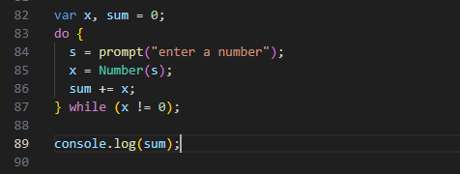

17. Write a program that takes a number from 1 to 7 and prints the corresponding day of the week using a switch statement. Use a for loop to test your program with all numbers from 1 to 7.

